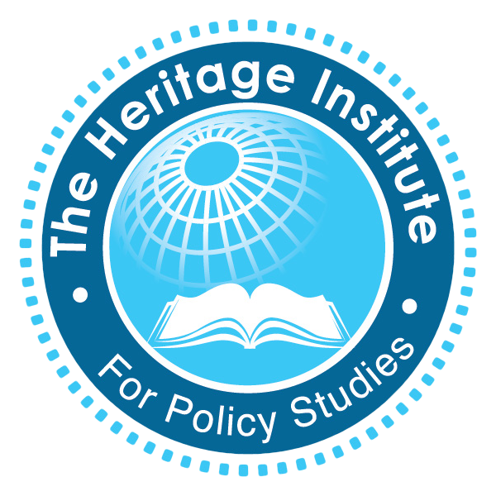
Internship Program
Application Form

The Heritage Institute for Policy Studies is an independent, nonpartisan, nonprofit policy research and analysis institute based in Mogadishu, Somalia.
Vision: To advance peace, the rule of law, and a culture of learning in Somalia
Mission: To inform public policy by providing independent empirical research and analyses, and creating an enabling environment for inclusive dialogue
Our internship program focuses on developing and nurturing future researchers through comprehensive skills training and by offering challenging research, writing, and advocacy opportunities in a wide range of policy issues.
Please send a completed application form along with all required supplementary materials in PDF format to info@heritageinstitute.org with “HIPS Internship Application” as the email subject.
Name
Phone
Email
Address
Academic Institution
Degree Title
Languages Spoken
Research Interests
Supplementary Materials:
Cover Letter explaining your interest in the Internship Program
Resume
Copy of Degree Certificate(s) / Transcript(s)
Samples of relevant research of coursework
Reference Letter

